Source or sink? The roles of glacier melt and sediment transport for the carbon budget of the Greenland Ice Sheet
Supervisors: Craig Smeaton (cs244@st-andrews.ac.uk), T.J. Young, Caroline Clason, Colm O’Cofaigh and Kelly Hogan.
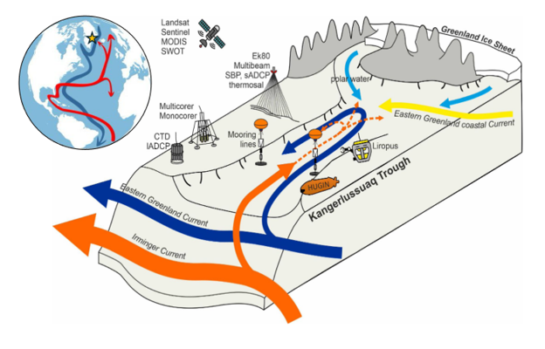
Rational: Approximately 80% of Greenland is covered by a massive ice sheet that holds around 7% of the Earth’s freshwater. The Greenland Ice Sheet sits above vast deposits of carbon-containing sediments, as well as holding significant amounts of organic carbon in ice, which is released into the surrounding environment through melting and iceberg calving where outlet glaciers reach the sea. When glaciers melt, the underlying sediment, which is rich in nutrients and minerals that represents various forms of organic matter, are washed into downstream fjords and from there into the outlying Atlantic Ocean via an underwater flow of meltwater. Despite their importance, Greenland’s fjords remain underrepresented in global carbon budgets, even though accelerated melt and retreat of the Ice Sheet is altering these ecosystems through increased freshwater discharge, iceberg calving, and the flux of sediments and other materials into fjord systems.
Figure 1. Conceptual schematic of inflows and outflows in the Kangerlussuaq Trough, Southeastern Greenland (starred in inset). Cold, fresh meltwaters enter the fjord from the Greenland Ice Sheet, bringing with it entrained sediment from inland (light blue arrows). Ocean currents (dark blue, red arrows) enter the fjord from its mouth and drive circulation within the fjord.
When sediment-laden meltwater enters a fjord, it forms a turbid plume that helps drive the circulation of water masses between fresh meltwater from the glacier and saline water from the ocean. Through this process, fine sediment particles remain suspended in the water and can travel far into the fjord and even onto the continental shelf, while coarser materials settle near the glacier front. Therefore, fjords act as natural sediment traps, preserving histories of glacial-landscape erosion within semi-enclosed basins, as well as representing a globally important but currently overlooked carbon sink.
To trace the origin of sediment and associated organic matter, geoscientists use biomarkers—molecular indicators that provide information about the origin, composition, and age of the organic material, whether this be from terrestrial vegetation, microbial communities on, in and under the ice, or marine sources. It is important to understand the composition of the dissolved and particulate carbon emanating from the glaciers, as this can be used to determine whether the carbon has a positive, neutral, or negative impact on the climate as it is released from source (glacier) to sea. Current estimates of the quantity of sediment exported from Greenland potentially exceeds 1000 million tonnes per year but the sparsity of data from around Greenland results in both the marine sediment and carbon budgets being poorly constrained.
Aim: Focusing on Kangerdlugssuaq Glacier in Southeast Greenland and its downstream fjord—one of the largest and most dynamic glacier systems of the Greenland Ice Sheet—the student will investigate the glaciological drivers controlling the organic carbon dynamics within the fjord as well as the larger Northwest Atlantic Ocean. Through a multidisciplinary approach that combines glaciology, sedimentology, biogeochemistry, and geomorphology, the student will:
- Investigate the quantity and pathways of meltwater discharge from Kangerdlugssuaq Glacier, using hydrological modelling approaches.
- Monitor sediment dynamics linked to the hydrologic outflow from glacier meltwater discharge, through satellite remote sensing of meltwater plumes at its terminus.
- Quantify and determine the composition of the carbon, through analysis of sediment cores obtained from the Kangerdlugssuaq Fjord.
- Establish the links between glacier meltwater discharge, sediment dynamics, and its organic carbon properties to facilitate creation of a first-order sediment and carbon budget for Greenland.
Methodology: This project leverages a unique but effective combination of remote sensing, glaciological modelling, and sediment / carbon analysis. Working with supervisors Young and Clason, the student will apply remote sensing algorithms in a big data framework (e.g. Lea 2018, Colosio et al. 2021) to determine the amount of ice discharged from Kangerdlugssuaq Glacier into the fjord, as either meltwater, or as iceberg calving. The pathway of meltwater often travels first from the surface to the bed of the glacier by intersecting crevasses and moulins (Clason et al., 2015), before then being routed to and through subglacial river networks to the glacier terminus. Through calculating the total amount of meltwater discharged from the glacier, the student can then obtain a first-order estimate of the amount of sediment discharged and deposited in the outlying fjord (Andreasen et al. 2024). The student will have the opportunity to analyse sediment cores collected in the Kangerdlugssuaq fjord and inner shelf, to reconstruct glacial dynamics over the recent past (~ the last 150 years). Samples from these cores will be used to quantify organic carbon export and burial through the application of bulk elemental analysis and the development of high-resolution age models. The composition and source of the carbon will be explored using stable isotope, ramped thermal and biomarker techniques. When combined with the glacial discharge data these approaches will allow us to constrain the proportion of carbon originating from the glacier (as opposed to other sources), and whether the composition of the carbon results in the Kangerdlugssuaq system being a net-source or sink of carbon in the North Atlantic.
Geophysical data and laboratory analysis underpins all stages of the project. To determine the amount of ice discharged, the student will leverage the Google Earth Engine Digitisation Tool (GEEDiT; Lea 2018), enabling rapid analysis of full-resolution optical satellite imagery to reconstruct a time series of glacier terminus positions. Concurrently, the student will also leverage models of glacier melt and meltwater transport (e.g. Clason et al. 2015) to measure the amount of ice mass lost through the melting of ice and the proportion of this meltwater reaching the bed of the glacier where it can interact with sediment stores. Sedimentological analysis of cores will be undertaken using high resolution core scanning approaches including XRF and CT scanning. A range of analytical approaches will be used, including bulk elemental and ramped thermal techniques to quantify the amount and reactivity of the carbon (Smeaton and Austin, 2022), stable isotopes, radionuclide dating (²¹⁰Pb, ¹³⁷Cs, ²⁴¹Am), radiocarbon and biomarkers such as IP25 to understand the age, source and composition of the carbon.

